Kegiatan Pra Event:
https://www.instagram.com/p/DeIiqaLO-Pd/?stkn=MWk2Y3hnaXQ2bzl4bw==
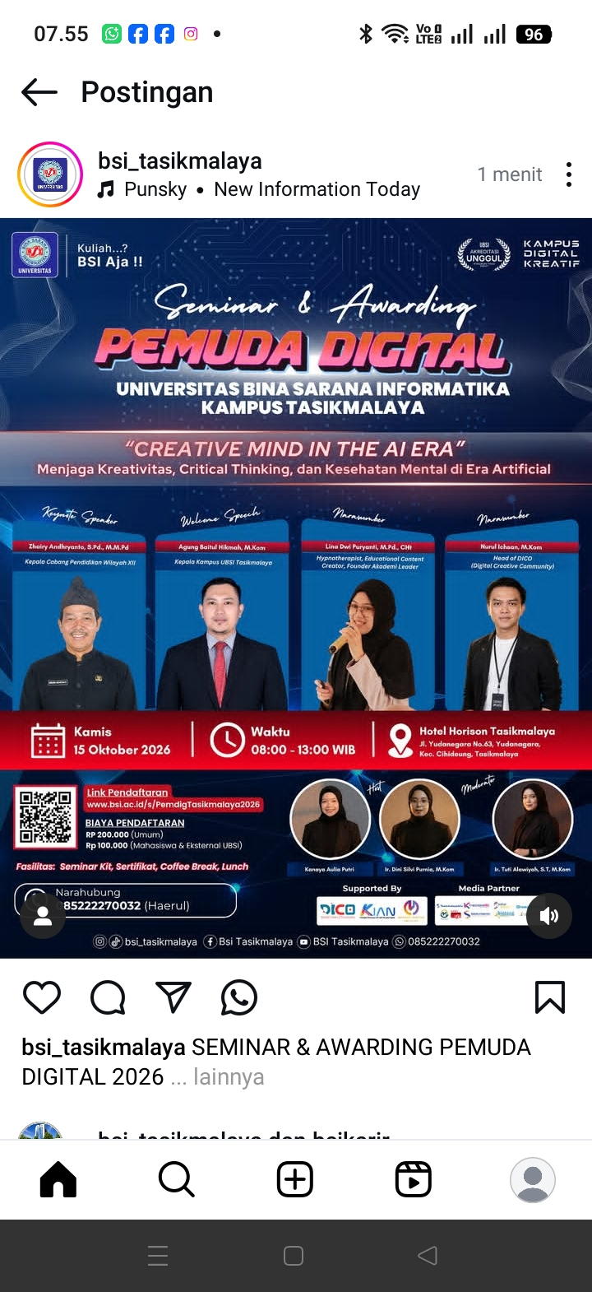
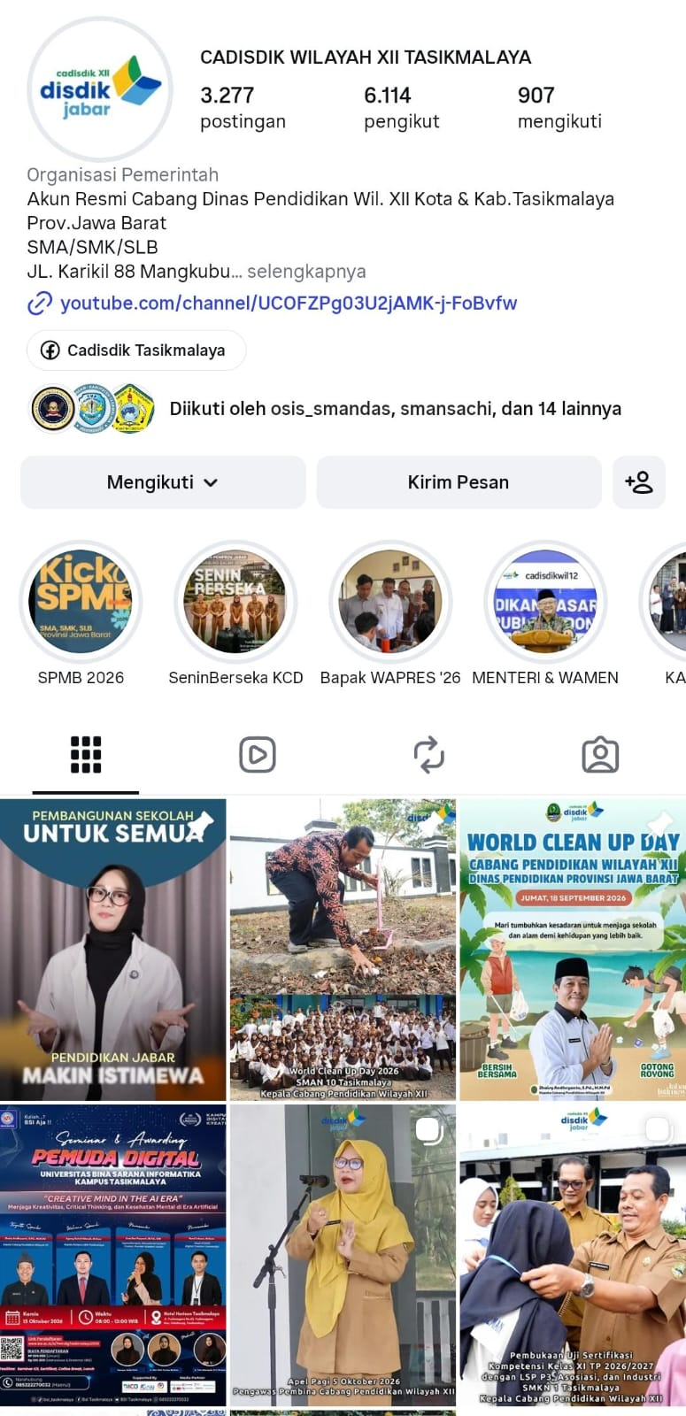
https://tasikmalayahitz.com/berita/seminar-pemuda-digital-ubsi-tasikmalaya/
